Load balancing concept Ec2

Step 1

First you create a two instance of two availability zones in a one region

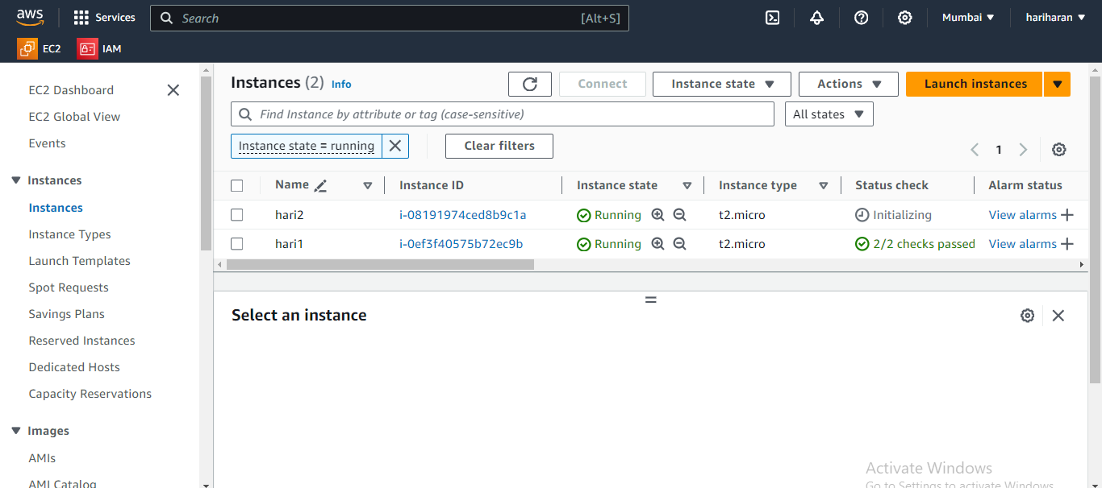

Step 2

Next you create target group

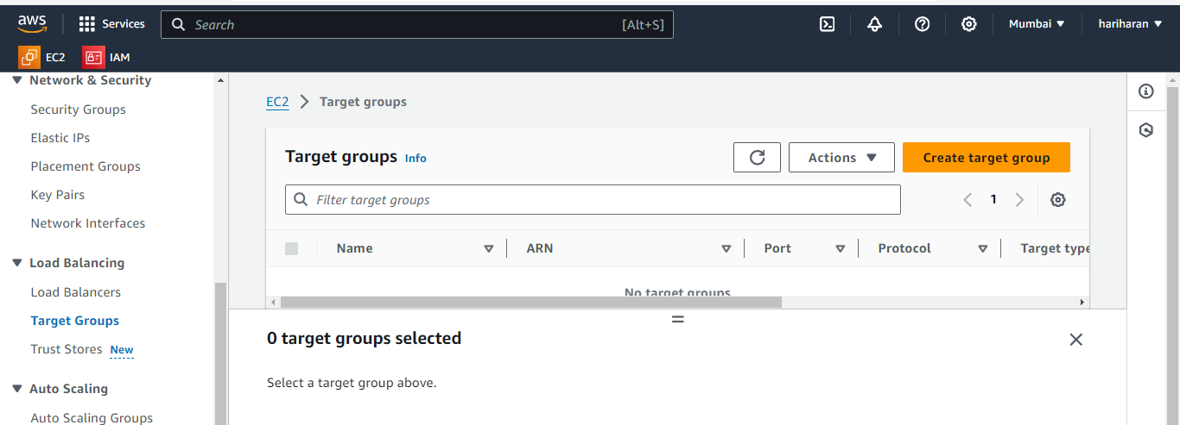

Specify group details target

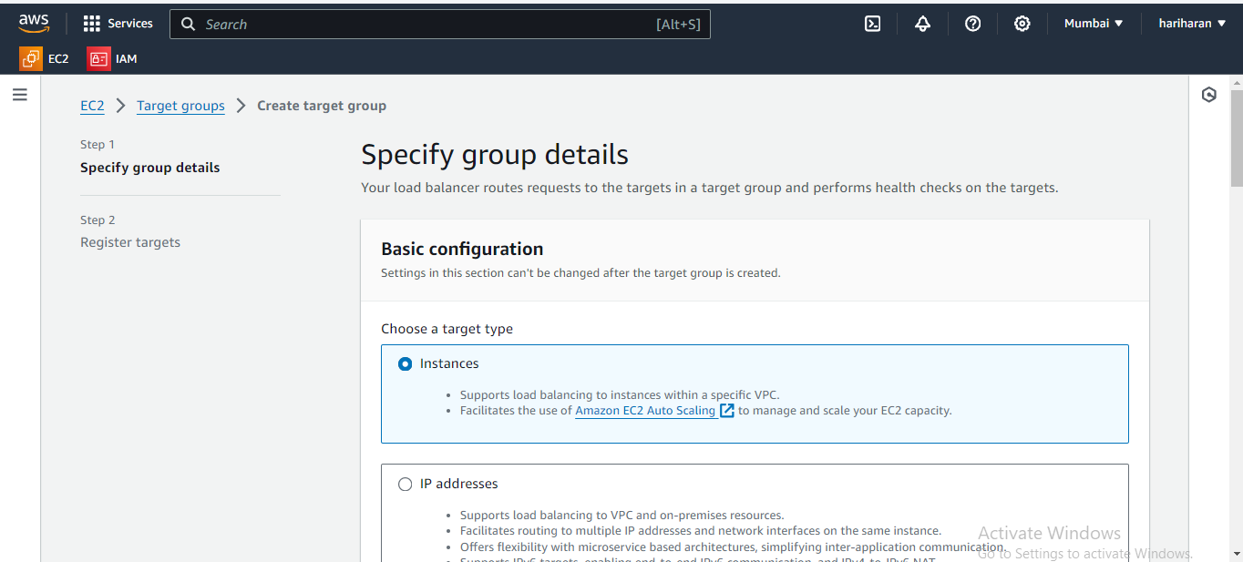

Register targets

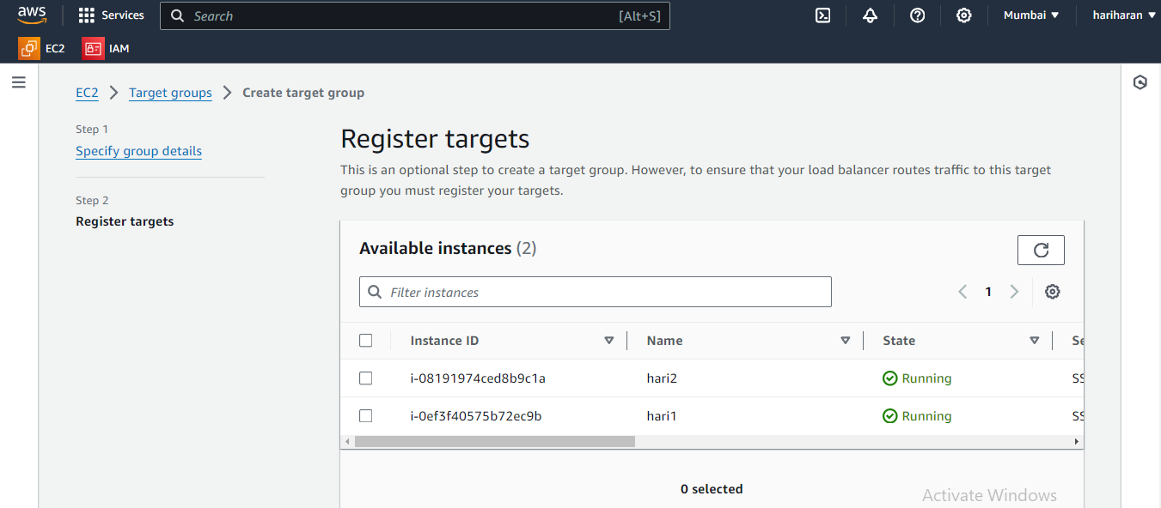

Review targets



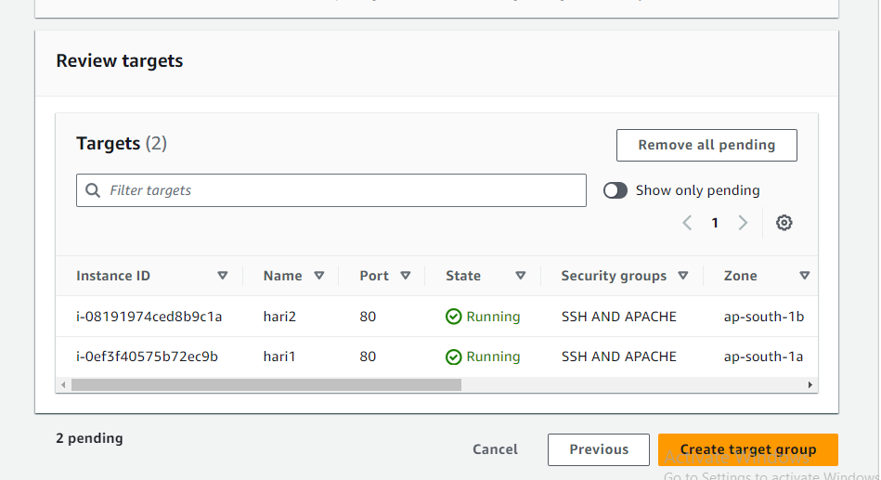

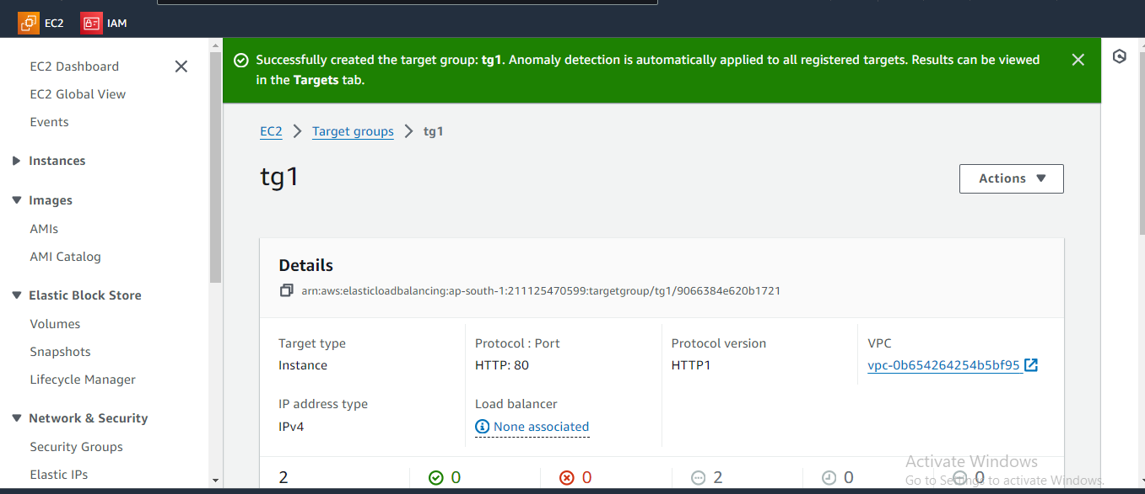

step 3

Application load balancer

* An **Application Load Balancer (ALB)** in AWS is a managed service within the Elastic Load Balancing (ELB) family, specifically designed to distribute HTTP and HTTPS traffic across multiple targets, such as EC2 instances, containers, and IP addresses.
* It operates at the **Layer 7** (Application Layer) of the OSI model, allowing it to make routing decisions based on content.

**Key Features of AWS ALB:**

1. **Layer 7 Routing**: ALB supports routing decisions based on various attributes such as HTTP headers, path, hostnames, and more.
2. **Host-based Routing**: You can route traffic to different targets based on the hostname, useful for multi-tenant applications or applications with multiple subdomains.
3. **Path-based Routing**: It enables routing based on the URL path (e.g., /api vs. /app), allowing more flexibility in directing traffic to the correct backend service.
4. **HTTPS Support with SSL/TLS Termination**: ALB allows you to terminate SSL/TLS connections at the load balancer, offloading encryption tasks from your backend services.
5. **WebSocket Support**: ALB supports WebSocket connections, enabling real-time communication between clients and servers.
6. **Target Groups**: ALB uses target groups to route requests. Each target group can have EC2 instances, containers, or Lambda functions as its targets. You can also perform health checks on the targets.
7. **Sticky Sessions (Session Persistence)**: The ALB can bind a user’s session to a specific target within the target group for the duration of the session.
8. **Cross-Zone Load Balancing**: ALB supports balancing traffic across multiple Availability Zones for high availability and fault tolerance.
9. **Integrated with AWS Services**: ALB integrates with services like **Amazon ECS**, **AWS Lambda**, **Amazon EKS**, **Auto Scaling**, and **Amazon CloudWatch** for enhanced scaling, monitoring, and management.

**Benefits:**

* **Improved Performance**: ALB distributes traffic efficiently, preventing any single server from becoming overloaded.
* **Security**: ALB works with AWS Web Application Firewall (WAF) to protect your web applications from common attacks.
* **Elasticity**: ALB can automatically scale based on the incoming traffic.

load balancing concept ec2

create load balancer

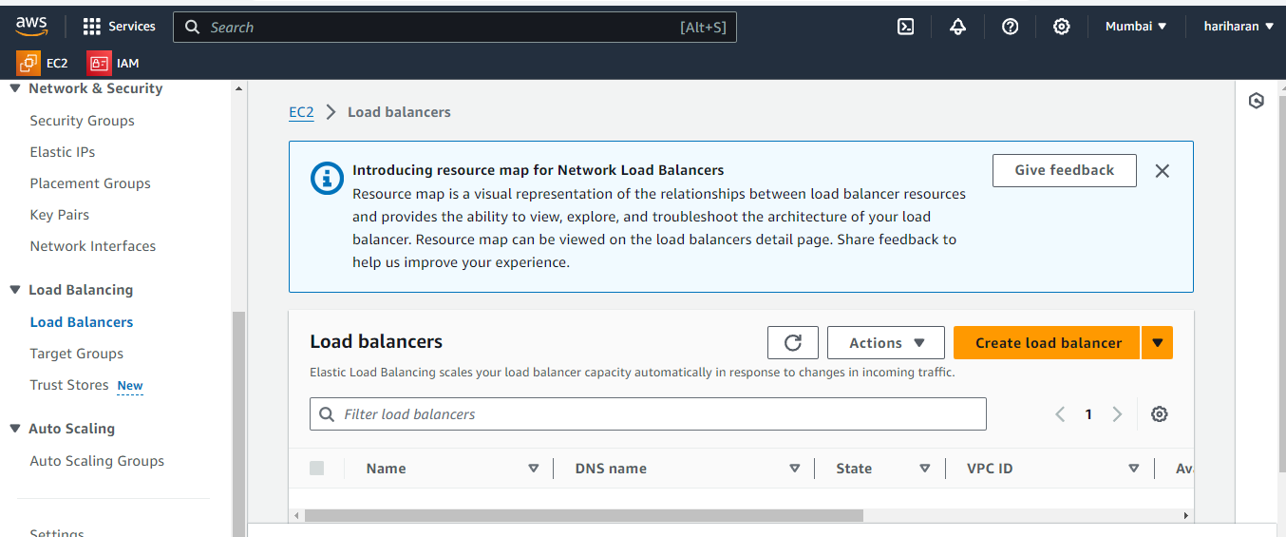

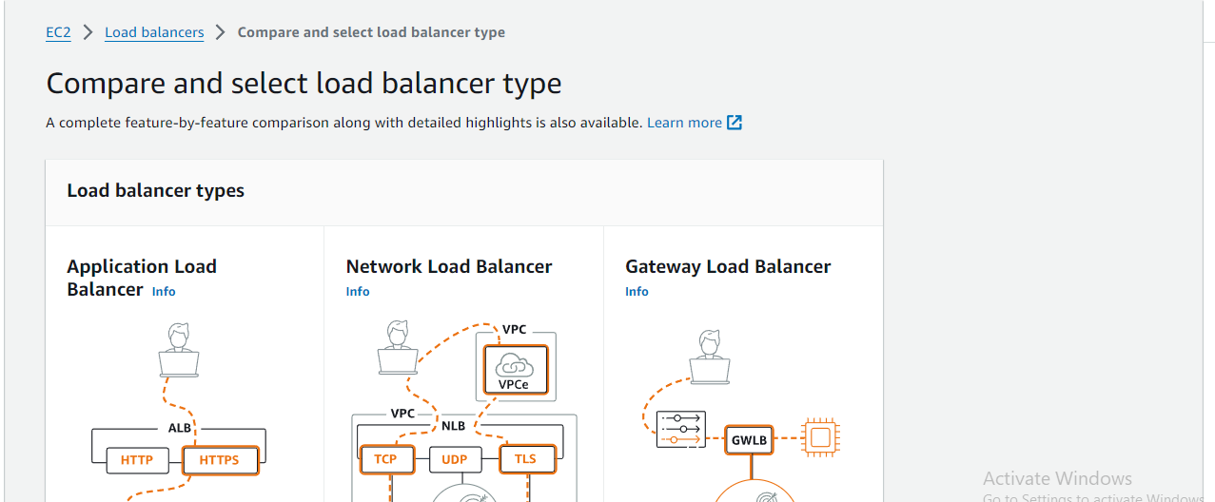

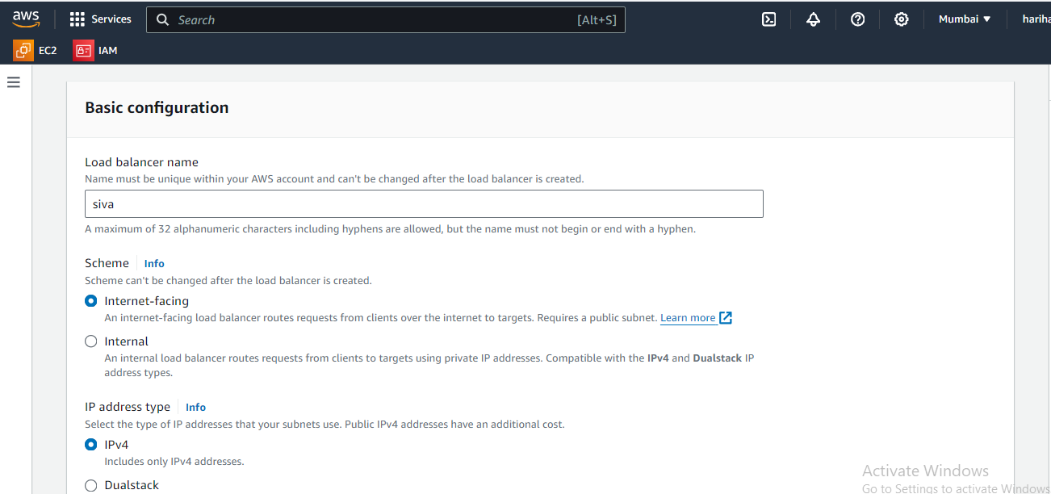

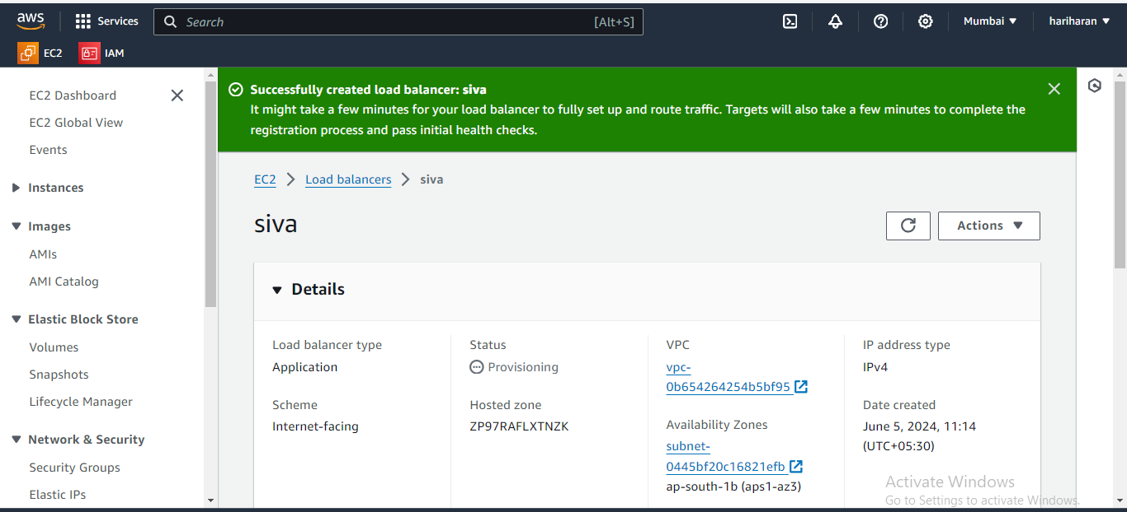DNS url copy to paste google

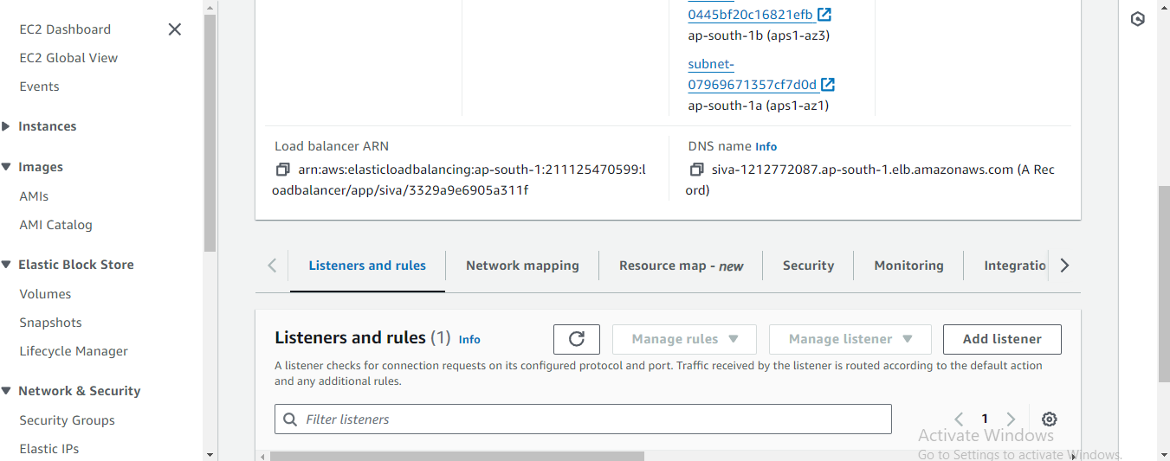

Note ouput





Last you delete load balance and also you ec2 instance

Type 2 load balance

Networking Load balancing

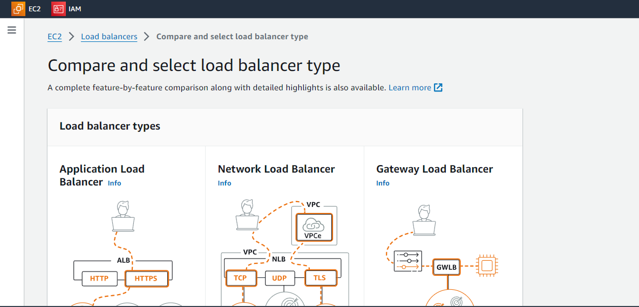

Create target group

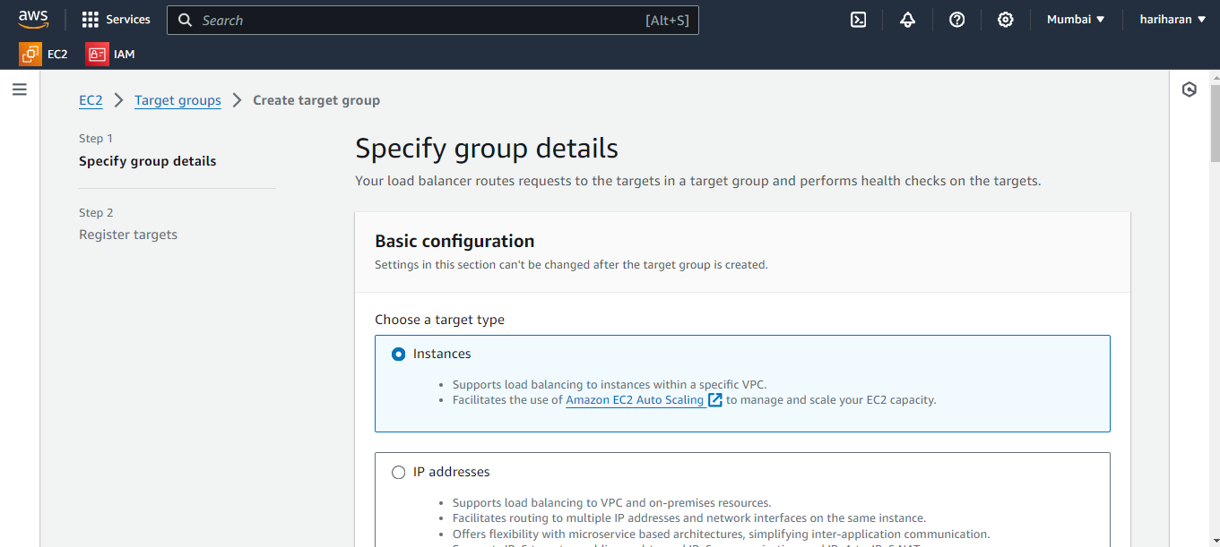

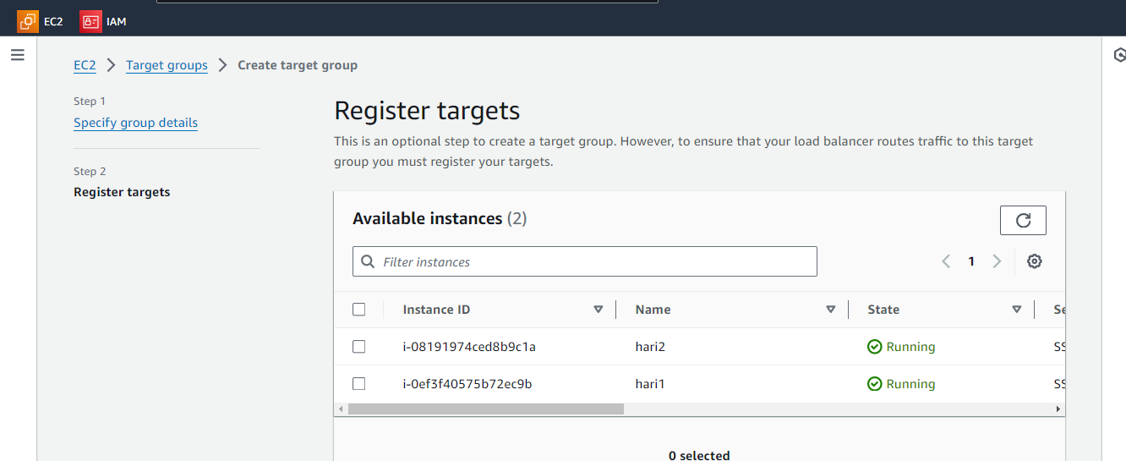

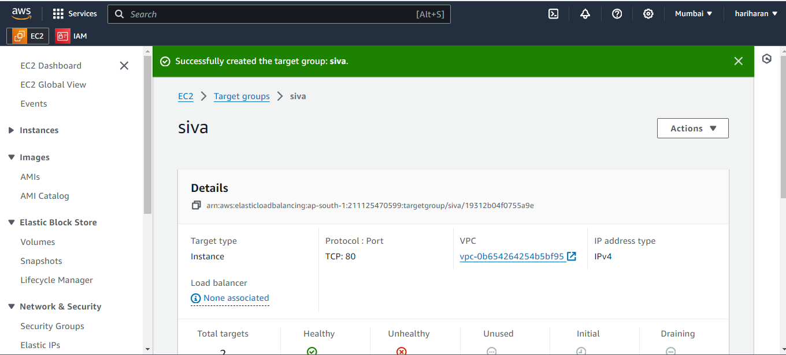

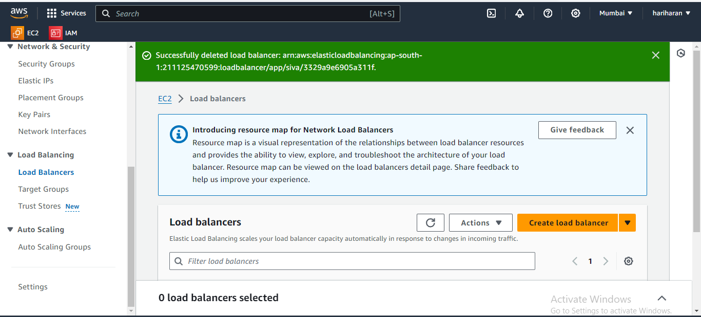

Network load balancer

